 NARROGIN SENIOR HIGH SCHOOL 

Foundation English

Student: Teacher:

Task 9: Look at the following still images from the movie September and answer questions 1 and 2 in the answer booklet.

Task 9: 5%
Reading
In class assessment – short answer responses to reading and visual texts studied throughout the semester

To be assessed for this task you must: | Date Due | YES | NO
Discuss SWAT codes

Teacher Feedback:

Reading | A | B | C | D | E
Language and expression | Identifies and explains vocabulary choices and language features and their effects in texts | Often identifies and explains vocabulary choices and language features and their effects in texts | Sometimes identifies and explains vocabulary choices and language features and their effects in texts | Rarely identifies and explains vocabulary choices and language features and their effects in texts | Does not meet the requirements of a D grade and/or has completed insufficient assessment tasks to be assigned a higher grade.
Mechanics of grammar, spelling and punctuation | Controls the mechanics of grammar, spelling and punctuation | Controls most of the mechanics of grammar, spelling and punctuation | Controls some of the mechanics of grammar, spelling and punctuation | Controls very few of the mechanics of grammar, spelling and punctuation | Does not meet the requirements of a D grade and/or has completed insufficient assessment tasks to be assigned a higher grade.
Structure | Organises response within a coherent structure | Organises response within a logical structure | Provides some structure for the response | Provides very little structure for the response | Does not meet the requirements of a D grade and/or has completed insufficient assessment tasks to be assigned a higher grade.
Supporting evidence and/or meeting the requirements of the task | Addresses all aspects of the task, providing relevant evidence (such as quotes and examples) where required to support understanding of texts | Addresses most aspects of the task, providing evidence where required to support understanding of texts | Provides some evidence to support understanding of texts | Provides very little evidence to support understanding of texts | Does not meet the requirements of a D grade and/or has completed insufficient assessment tasks to be assigned a higher grade.
Writing | A | B | C | D | E
Language and expression | Usually controls vocabulary and language features for clarity of expression, development of voice and awareness of audience | Often controls vocabulary and language features for clarity of expression, development of voice and awareness of audience | Sometimes controls vocabulary and language features for clarity of expression and awareness of audience | Rarely controls vocabulary and language features for clarity of expression and awareness of audience | Does not meet the requirements of a D grade and/or has completed insufficient assessment tasks to be assigned a higher grade.
Mechanics of grammar, spelling and punctuation | Controls the mechanics of grammar, spelling and punctuation | Controls most of the mechanics of grammar, spelling and punctuation | Controls some of the mechanics of grammar, spelling and punctuation | Controls very few of the mechanics of grammar, spelling and punctuation | Does not meet the requirements of a D grade and/or has completed insufficient assessment tasks to be assigned a higher grade.
Structure | Organises ideas in an effective structure at sentence, paragraph and whole text level | Usually organises ideas in an appropriate structure at sentence, paragraph and whole text level | Sometimes organises ideas at sentence, paragraph and whole text level | Rarely organises ideas at sentence, paragraph and whole text level | Does not meet the requirements of a D grade and/or has completed insufficient assessment tasks to be assigned a higher grade.
Supporting evidence and/or meeting the requirements of the task | Addresses all aspects of the task, providing relevant detail where required | Addresses most aspects of the task, providing detail where required | Addresses some aspects of the task, at times providing detail | Addresses very few aspects of the task, rarely providing detail | Does not meet the requirements of a D grade and/or has completed insufficient assessment tasks to be assigned a higher grade.

Q1: Think about the composition of this image. Where are the objects and people arranged in the frame? What camera angle and shot is used? What effect does this have?
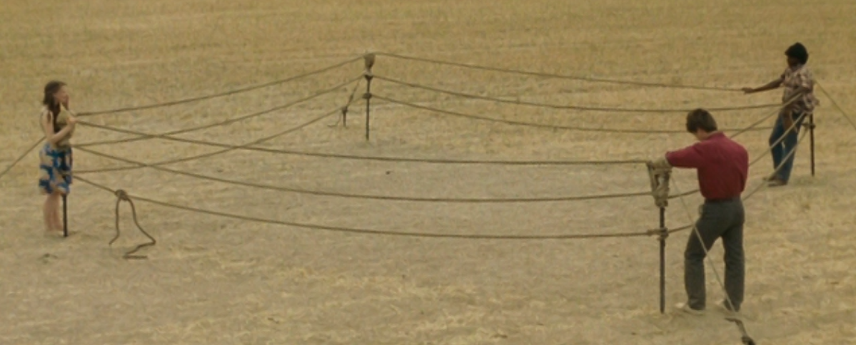

Q2: Look at the following still image and the dialogue taken from this scene. What does it tell us about Paddy’s character?

Paddy: “I’m getting out of here anyway.”
Ed: “What do you mean?”
Paddy: “I’m going to join that boxing mob.”
Ed: “You?”
Paddy: “What? You think I want to stay here and end up working for you?”

